Locating an Epicenter by Triangulation
Mrs. Cohn

Name:__________________________________________ Block/Day:________

Intro: Earthquakes are generated along faults. The friction between rock masses (of plates) rubbing against one another (whether diverging, converging or sliding past) builds up as the rock bends elastically. When rock reaches its elastic limit, it snaps, giving off energy in the form of seismic waves. These waves are radiated outwards from the focus, or point at which break in the fault and movement actually takes place. The point directly above the focus on the surface is referred to as the epicenter. It’s rare that you will be at the epicenter when an earthquake occurs; however, many regions receive these seismic waves only minutes and seconds after. The closer you are to the epicenter, the stronger the waves will feel, and the closer they will arrive to one another.
Most earthquakes are too weak for humans to notice, however, they are recorded by seismographs. Seismographs produce seismograms which depict the seismic waves; the wave height (amplitude) as well as the time they occurred. There are three different waves that can be recorded on a seismogram; P, S, and L waves, each with a larger amplitude (wave height) then the previous.

Vocabulary Review

Epicenter:

Seismogram:

Travel Time:

Origin Time:

Part A. Pre-Lab Questions:

- How do P and S waves differ in speed and in the type of mediums they travel through?

- How does the time of arrival between the arrival of P and S-waves change as one gets further from the epicenter?

- Using your explanation to question 2, infer which station is the furthest from the epicenter using the seismograms provided on page 2 of this lab.

- Using only the amplitude of the seismic waves provided on page 2 of this lab, infer which station is the closest to the epicenter. Explain your choice.
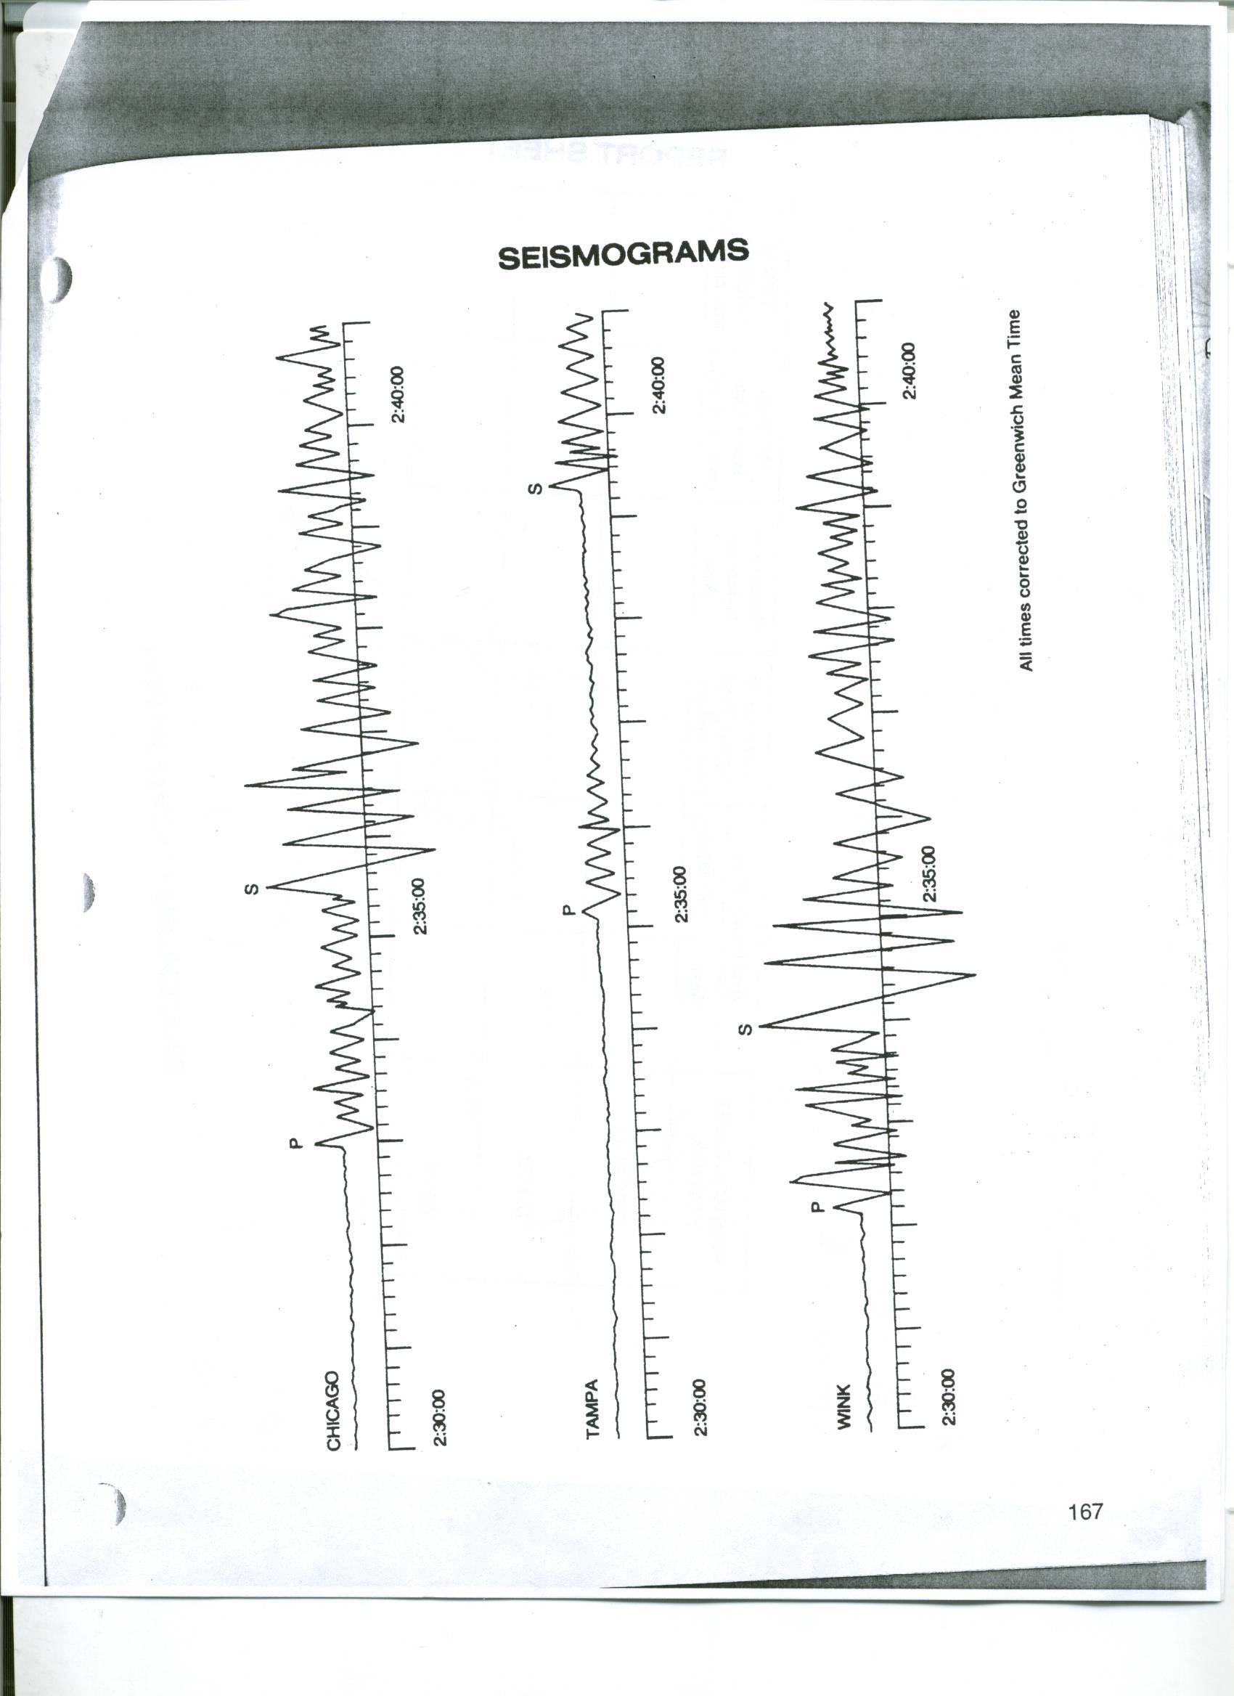
Seismic Station | P-Wave Arrival Time | S Wave Arrival Time | S-P time Interval | Distance to the Epicenter (km) | P-Wave Travel Time | Origin Time
Chicago
Tampa
Wink
Directions:

- Using the three seismograms given, report the P and S wave arrival times with the time format 00:00:00 for hours, minutes, seconds.
- For each seismic station, determine the S-P time interval in minutes and seconds, 00:00
- Mark the S-P time interval for each seismic station on a piece of scrap paper using the y axis on pg. 11 of your ESRT for travel time.
- Drag your piece of paper along the P and S wave graph curves until the time interval you marked aligns exactly to fit the appropriate time interval with both the P and S wave travel time curves. Read the X-axis to determine the distance to the epicenter.
- Using this distance, determine the P-wave travel time (y-axis)
- Solve for the origin time of the earthquake using the P wave arrival time and the P-wave travel time.
(Time or origin= P arrival time- P travel time).

- Once you have successfully completed the data table above, use the found distances to the epicenters for each of the three seismic stations to determine where the epicenter actually occurred
  - Take a piece of scrap paper, and for each seismic station, use the map scale to determine the scaled distances to the epicenter. Do this for each seismic station separately/not all on one side of the paper.
  - Use the scaled distances to mark on the map (page 5) the radius length of each circle you will draw for each seismic station (Chicago, Tampa, Wink)
  - Hold your compass so that the metal ring at the center of the compass aligns directly with the location of the seismic station city on the map.
  - Place your sharpened pencil in the closest opening/hole within the compass ruler that matches the scaled distance you marked on your map.
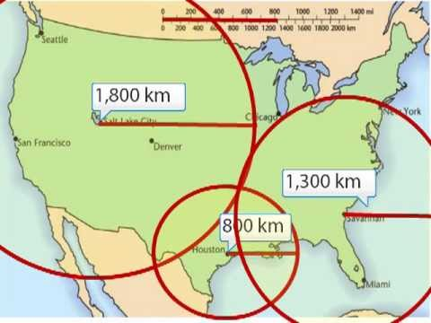
  - Holding the center of the compass so that the metal ring does NOT MOVE from the correct city, pivot your drawing hand around the center of the compass so that you have now drawn a circle with a radius equal to the distance to the epicenter.
  - Repeat this for all three seismic stations until you have three circles drawn, all with different radii to represent the distances to the epicenters you found.
  - Mark the location of the epicenter with an “x”

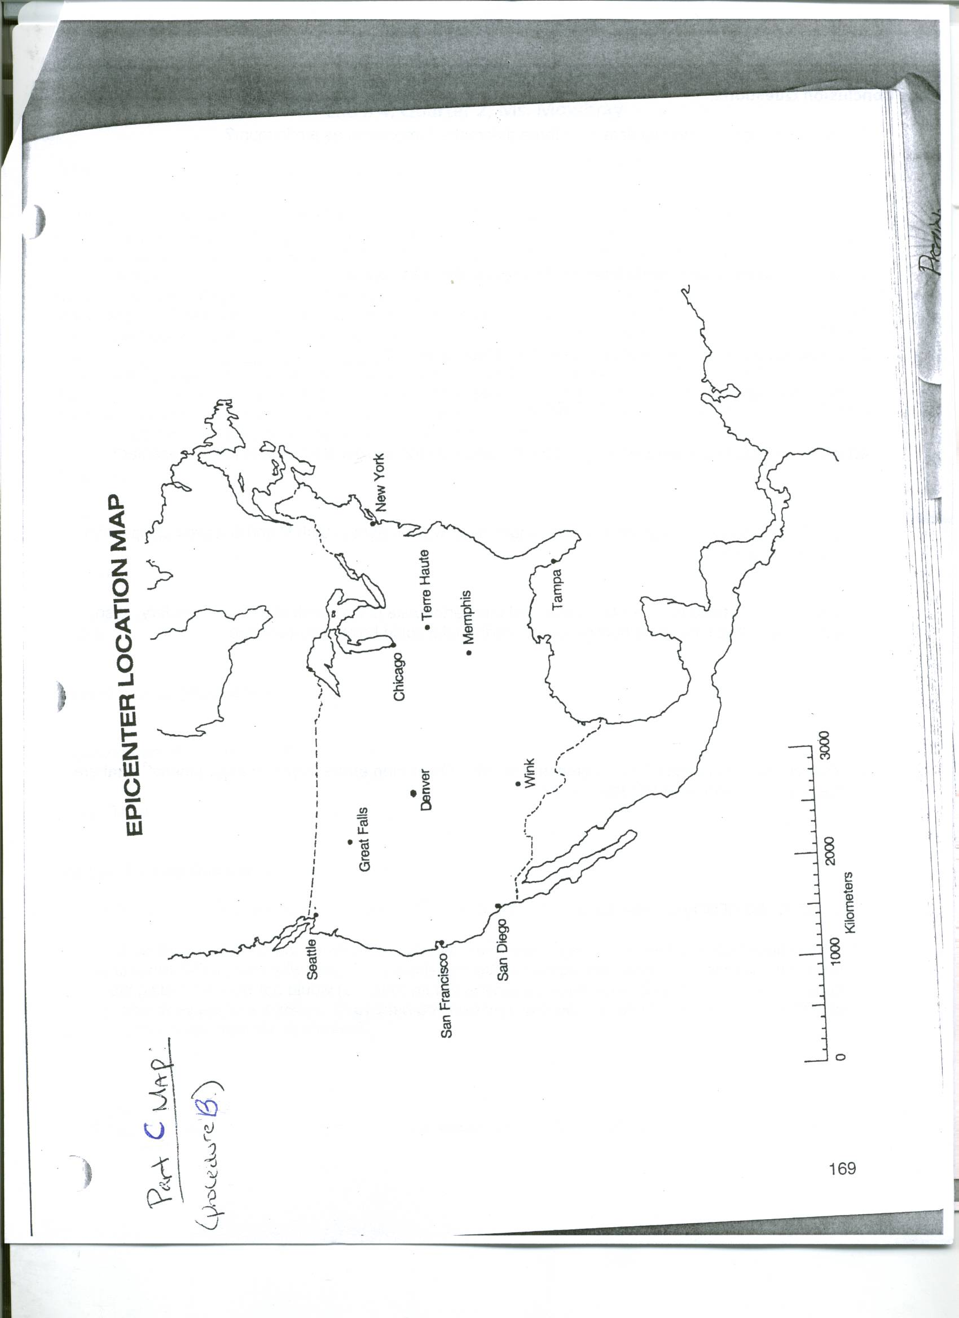

Conclusion Questions:

- How many seismic stations, minimum, are needed to located an epicenter?

- Where was the approximate location of the epicenter? (use compass directions and proximities to major cities if needed in your description

- Which seismograph recorded the earliest P-wave arrival?

Which seismograph recorded the latest P-Wave arrival?

- Which station was closest to the epicenter?

Which station was the furthest away?

- Use your plate tectonics map to determine if this earthquake was the result of a plate boundary. If so, which type of boundary and which plates were involved? If not, describe what other tectonic features are in proximity to the epicenter that could cause an earthquake to occur.

- Do P and S waves always travel at the same speed as they move through earth’s interior, why or why not?

- A magnitude 9 Earthquake struck Japan in 2011. Many locations around the world received seismic waves, and some were subject to the aftershocks. Explain why Buenos Aires, Argentina (South America) would not work as a suitable seismic station to find the distance to the epicenter. Hint: Use a globe to help justify your answer.

- The deadliest earthquakes, such as the one in Japan, are created along which type of plate boundary?

- Other than the earthquake itself (seismic energy), based on Japan’s geographic location, what other major threat were the Japanese subject to after the earthquake occurred?

